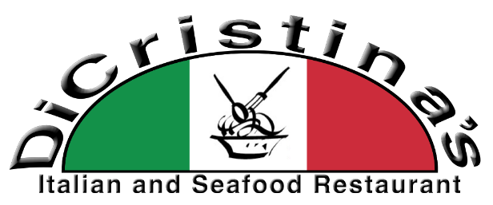
226 E. Lockwood Street
Covington, LA 70433
Phone 985 875●0160 Fax 985 809●2179
Tuesday – Thursday 10:30am – 9:00pm
Friday 10:30am – 10:00pm
www.DiCristinas.com Saturday 11:00am – 10:00pm

Friday, April 24, 2026
Appetizers and Soup of the Day:

Crabmeat and Brie Soup Seafood Gumbo
Cup - $ 8 Bowl - $ 11

^{New} Fried Mozzarella ^{New} Stuffed Artichoke
$ 13 $ 16

^{New} Italian Chips and Salsa ^{New} ^{New} Crispy Shrimp Wraps ^{New}
Red Gravy Feta and Mozzarella Cheeses Served with House Made Potato Chips Served with Pepper Jelly Vinaigrette Dipping Sauce
$ 9 $ 14

^{New} Charbroiled Oysters ^{New} ^{New} Crawfish Bread ^{New}
Half Dozen - $ 16 Dozen - $ 26 $ 14

Specials:

Py’s Firecracker Shrimp PoBoy Chicken & Sausage Jambalaya Blackened Chicken Thigh PoBoy
Fried Shrimp Tossed in Pepper Jelly Vinaigrette Sauce $ 13 Half $ 11 Whole $ 15
Half $ 14 Whole $ 18

Shrimp Stuffed Bell Pepper with Baked Macaroni and Sautéed Green Beans
$ 21

Fried or Blackened Catfish with Shrimp Eggplant Dressing
$ 22

Blackened Pork Chops with Candied Brussel Sprouts and Smashed Garlic Potatoes
$ 19 **Nut Allergy**

Sicilian Shrimp Alfredo over Fettuccine
$ 21

Fried Catfish with Chicken and Sausage Jambalaya
$ 20

Cheese Ravioli with Grilled Shrimp in a Crabmeat Cream Sauce
$ 25

Blackened Shrimp with Cajun Alfredo over Bowtie Pasta
$ 26

Grilled Tripletail over Grits and topped with Crawfish Sauce
$ 24

Fried or Broiled Trout and Crabmeat Sauce with Sautéed Green Beans and Smashed Cauliflower
$ 24

FISH OF THE DAY: TripleTail (white flaky fish with a mild flavor)
Served with Choice of Side and a Small House Salad
$ 26 Some Sides may include an upcharge

Blackened Chicken Theeaux
Blackened Chicken in a Homemade Wine Sauce over Bowtie Pasta
$ 24

Order Online and see our Specials at www.dicristinas.com

